***Python***

**Python was first released by Guido van Rossum in February 1991.**

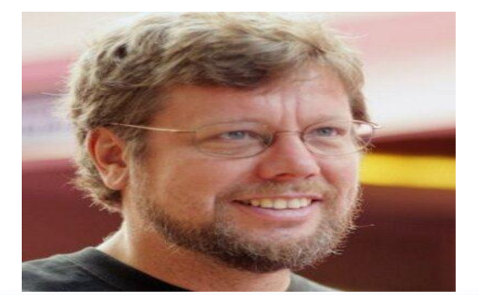

**What is programming language ?**

* A programming language is a way for programmers (developers) to communicate with computers.

Programming languages consist of a set of rules

**What is High Level Language?**

*) High level languages are easier to understand for humans because it uses lot of symbols letters phrases to represent logic

and instructions in a program

*) high level language all of their compiled and interpreter language

**Python is compiled and interpreted language**

**How Python Internally Works?**

**Code Editor**: is the first stage of program. This is human-readable code written according to Python’s syntax rules.

It is where the execution of the program starts first.

**Source code :** The code written by a programmer in the code editor is then saved as a .py file in a system.

This file of Python is written in human-readable language that contains the instructions for the computer.

**Compilation Stage:** python compiles a source code into a byte code. In the compilation stage python compiler also checks for syntax errors. After checking all the syntax errors, if no such error is found then it generates a .pyc file that contains bytecode.

**Python Virtual Machine(PVM):**The bytecode then goes into the main part of the conversion is the Python Virtual Machine(PVM).

The PVM is the main runtime engine of Python.It is an interpreter that reads and executes the bytecode file,line by line.

Here In the Python Virtual Machine translate the byte code into machine code which is the binary language consisting of 0s and 1s

**Running Program:** At last, the CPU executes the given machine code and the main outcome of the program comes as performing task

**python is a object oriented language**

**why python is object oriented language?**

*) python is allows for class and objects

**oops:**

*)Object-oriented programming began with the Simula language (1967)

**python infulunced by ABC,Modula-3,c**

**Where is python used ?**

* data science

* desktop application

* console based application

* mobile application

* software development

* AI

* web application

* enterprise application

* 3D cad application

* ML

* speech recognition

* education

* testing

* gaming

* IoT

* networking

* writing Scripts

**python vs java?**

python in 1991

java in 1995

tell about the graph of the two languages

Here are some basic programs that illustrates key differences between them.

Printing 'Hello World'

**Python Code:**

print("Hello World)"

In Python, it is one line of code. It requires simple syntax to print 'Hello World'

Java Code:

public class HelloWorld {

public static void main(String[] args) {

System.out.println("Hello, World!");

}

}

In Java, we need to declare classes, method structures many other things.

**Features:**

**1. Easy to Learn and Read:** Python's syntax is designed to be simple and easy to understand, making it an ideal language for beginners.

2. **Expressive Language :** python allows developers to write clear and conced code in one line

3. **High-Level Language**:developer to focus on solving problemsrather than dealing with system -level details

4. **Extensive Standard Library**: oython comes with a packages for various tasks,such as file i/o,networking,string manipulation and more...

5. **platform-independent and open source :** Python is available on various platforms, including Windows, macOS, and Linux, making it suitable for developing applications that can run on multiple operating systems without modification. python can easily installed on windows ,macOS,linux with cost - free.

6. **Garbage Collected** - Memory allocation and de-allocation are automatically managed. Programmers do not specifically need to manage the memory.

7. **GUI** - Grapical User Interface also included in python